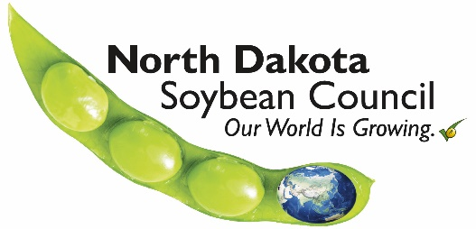
NDSC Funding Request Form

Date:
Name of Organization:
Project Contact’s Name & Title:
Address:
City:
State:
Zip Code:
Email Address:
Phone Number:

Project Title:
Project Total Cost:
Amount Being Requested from NDSC: $
______________________________________________________________________________
For NDSC to complete:
Received on: __/__/____ Funding request for FY____
- Please describe the project for which funding is being requested, including your goals and objectives; event or project promotion plans.
- Outline how you will measure & report project success.
- Describe how North Dakota soybean farmers will benefit from this project.
- What is the start and end date of this project?
- What is your organization’s fiscal year?
- How will NDSC be recognized?
- List the other sources of funding for the project and their dollar amounts.
- Please include a short project budget outline.
- If this project has been funded previously by NDSC, please explain any significant increases or decreases in the funding amount being requested.
- Does your organization conduct any lobbying or legislative activities? YES or NO
Requirements for Funding:
- Projects must have a direct benefit to ND soybean producers.
- Only completed NDSC Funding Request Forms will be considered. The form can be accessed online at: www.ndsoybean.org
- Submit completed funding requests by email to Molly Fern, NDSC Director of Finance at mfern@ndsoybean.org
- If approved for funding, you will be required to give written and/or verbal reports to NDSC at times specified in finalized project contracts.
- Contact the NDSC office for deadline dates for submitting NDSC Funding Request Forms: 701-566-9300.
Funding Requests will NOT be accepted for the Following Activities:
- Legislative or lobbying efforts.
- Political campaigns.
- Programs or activities that personally benefit employees or directors of the NDSC.
- Programs or activities that directly benefit a specific individual or private business.
- Humanitarian efforts.
- General fund support or sponsorships.
- Programs that do not have a direct benefit to ND soybean producers or the ND soybean industry.

For additional questions contact the ND Soybean Council
www.ndsoybean.org
701-566-9300

