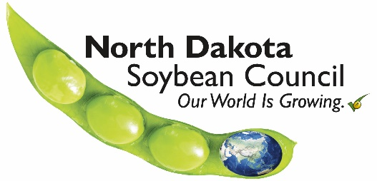
NDSC Funding Request Form

Date:
Name of Organization:
Requester’s Name & Title:
Address:
City:
State:
Zip Code:
Email Address:
Phone Number:

Project Title:
Amount Being Requested: $
______________________________________________________________________________
For NDSC to complete:
Received on: __/__/____ Funding request for FY____
- Please describe the project for which funding is being requested, including your goals and objectives.
- What is the start and end date of this project?
- What is your fiscal year?
- Outline how your project objectives will be measured and how will you measure success.
- List how you will promote your project or event and how you will communicate end results.
- Describe how North Dakota soybean farmers will benefit from this project.
- What is the total cost of your project and what dollar amount are you requesting from the North Dakota Soybean Council?
- List the other sources of funding for the project and their dollar amounts:
- How will NDSC be recognized?
- Does your organization conduct any lobbying or legislative activities? YES or NO
Requirements for Funding:
- Projects must have a direct benefit to ND soybean producers.
- Only completed NDSC Funding Request Forms will be considered. The form can be accessed online at: www.ndsoybean.org
- Submit completed funding requests by email to Molly Fern, NDSC Director of Finance at mfern@ndsoybean.org
- If approved for funding, you will be required to give written and/or verbal reports to NDSC at times specified in finalized project contracts.
- Contact the NDSC office for deadline dates for submitting NDSC Funding Request Forms: 701-566-9300.
Funding Requests will NOT be accepted for the Following Activities:
- Legislative or lobbying efforts.
- Political campaigns.
- Programs or activities that personally benefit employees or directors of the NDSC.
- Programs or activities that directly benefit a specific individual or private business.
- Humanitarian efforts.
- General fund support or sponsorships.
- Programs that do not have a direct benefit to ND soybean producers or the ND soybean industry.
- Funding to Foundations or for endowments.
- Brick and mortar projects.
Updated Oct 2018
For additional questions contact the ND Soybean Council
www.ndsoybean.org
701-866-9300

