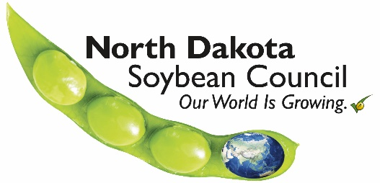
Funding Request Form

Date:
Name of Organization:
Address:
City: State: Zip Code:
Email Address: Phone Number:
Requester’s Name: Title:
Project Title:
Amount Being Requested:
- Please describe the project for which funding is being requested, including your goals and objectives.
- How will this project improve soybean yield, quality and/or profitability for North Dakota soybean producers?
- How will your project objectives be measured?
- How will you measure success? Define what project success will look like.
- What is the start and end date of this project?
- How will North Dakota soybean farmers benefit from this project?
- How will your project increase demand for ND soybeans and/or soy products?
- What is the total cost of your project and what dollar amount are you requesting from the North Dakota Soybean Council?
- List the other sources of funding for the project and their dollar amounts:
- How will funding contributors be recognized?
- What is your fiscal year?
- Does your organization conduct any lobbying or legislative activities?
Requirements for Funding:
- Projects must have a direct benefit to ND soybean producers.
- Requesters must complete and submit a “Funding Request Application Form” available on our website at www.ndsoybean.org
- Funding proposals are accepted in November for consideration in December and in May for consideration in June. Contact NDSC’s office for submission deadline annually.
Funding Requests will not be accepted for the Following Activities:
- Legislative or lobbying efforts
- Political campaigns
- Programs or activities that personally benefit employees or directors of the NDSC
- Programs or activities that directly benefit a specific individual or private business
- Humanitarian efforts
- General fund support or sponsorships
- Programs that do not have a direct benefit to ND soybean producers or the ND soybean industry
- Funding to Foundations or for endowments
- Brick and mortar projects
Questions and Submission:
- Questions: contact the ND Soybean Council office at 701-566-9300
- Submit to the ND Soybean Council at 4852 Rocking Horse Circle South, Fargo, ND 58104 or via e-mail to ssinner@ndsoybean.org

